Puff Pastry Pockets

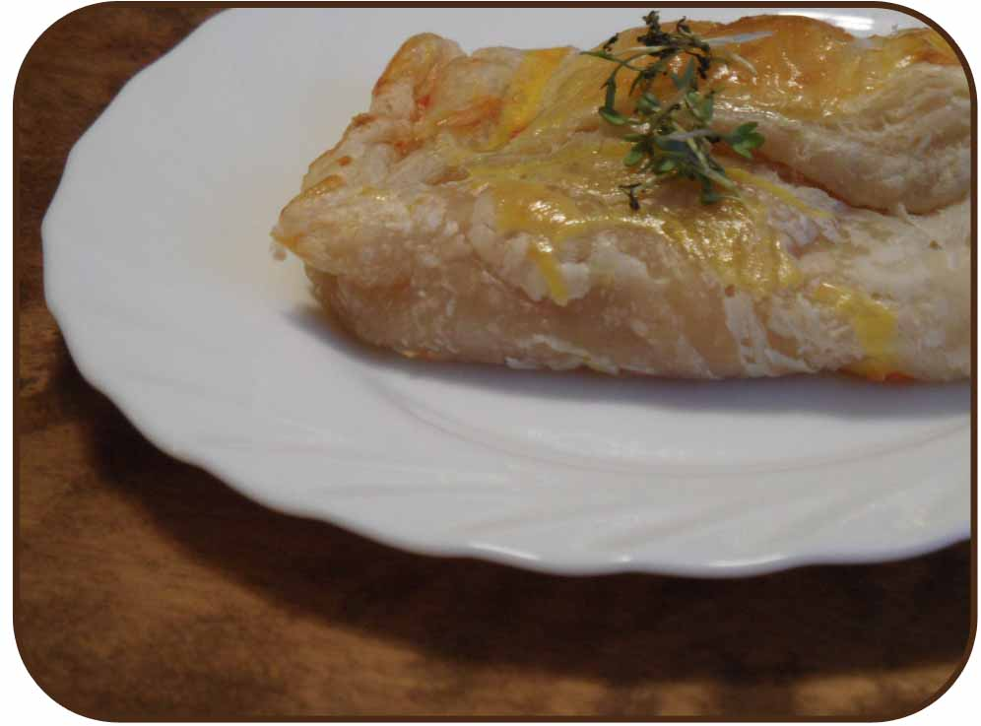

Ingredients:
As many slices of ready-to-use puff pastry as you want to eat and the filling you prefer (e.g. tomatoes, bell pepper, ketchup, cheese, feta, corn...) cut into eatable pieces. Egg yolk.

Preparation:
Roll out the puff pastry, fill with your fillings and form a pocket. Brush with egg yolk. Bake for app. 20 minutes at 200°C.

Enjoy!

